NO CHEATERS AMONG US

RemoteAssmt - 2

Shabarish Ramaswamy
Abhishek Joshi
Shlok Naik
Aakriti Sharma

Software Requirement Specification Report

Table of Contents
1. Introduction....................................................................................... 1
1.1 Purpose........................................................................................... 1
1.2 Project Scope................................................................................... 1
2. Overall Description........................................................................... 2
2.1 Product Perspective.......................................................................... 2
2.2 Product Features............................................................................... 2
2.3 User Classes and Characteristics....................................................... 2
2.4 Operating Environment..................................................................... 2
2.5 Design and Implementation Constraints............................................. 2
2.6 User Documentation......................................................................... 2
2.7 Assumptions and Dependencies........................................................ 3
3. System Features................................................................................. 3
3.1 System Feature 1.............................................................................. 3
3.2 System Feature 2 (and so on)............................................................ 4
4. External Interface Requirements..................................................... 4
4.1 User Interfaces................................................................................. 4
4.2 Hardware Interfaces......................................................................... 4
4.3 Software Interfaces........................................................................... 4
4.4 Communications Interfaces............................................................... 4
5. Other Nonfunctional Requirements................................................ 5
5.1 Performance Requirements............................................................... 5
5.2 Safety Requirements......................................................................... 5
5.3 Security Requirements...................................................................... 5
5.4 Software Quality Attributes............................................................... 5
6. Other Requirements.......................................................................... 5
Appendix A: Glossary............................................................................. 5
Appendix B: Analysis Models................................................................ 6
Appendix C: Issues List.......................................................................... 6

1. Introduction

1.1 Purpose
- Currently due to COVID all the exams are conducted online. We have personally experienced that in this mode of examination there is a lot of copying and other malpractices.
- One teacher is required for 3-4 students to ensure that such activities are not happening but this is not feasible. Thus we have to develop modern, elegant, and innovative solutions for this problem.
- Moreover the cost of such activity is enormous going up to 10s or 100s of crores.
- Students who cheat the system and get ahead are not only utilizing important government and other resources but they are also not allowing underprivileged students who give exams legitimately, the chance to come forward in life and thus ending their poverty cycle.
- Legitimacy in answering and understanding is a must for the student to grow, develop and in turn help the society from the knowledge they have obtained. We can say that this is the backbone of Innovation, Modernization, Advancement in STEM and to create intelligent modern citizens who can propel the country from Developing to Developed.

1.2 Project Scope
- The main objective of this project is to provide a secure and interactive platform to conduct and monitor tests.
- It is an unsupervised platform wherein login functionality is provided to students and teachers(admin).
- The application seeks to provide a solution for the following issues:
- Fraud and Malpractice regulation and detection in an unsupervised manner
- Making monitoring easier and automated
- Making an interactive and simple platform to host and conduct online tests
- Provide an integrity score report using which students and teachers can both have proof for their respective stances.

2. Overall Description

2.1 Product Perspective
<Describe the context and origin of the product being specified in this SRS. For example, state whether this product is a follow-on member of a product family, a replacement for certain existing systems, or a new, self-contained product. If the SRS defines a component of a larger system, relate the requirements of the larger system to the functionality of this software and identify interfaces between the two. A simple diagram that shows the major components of the overall system, subsystem interconnections, and external interfaces can be helpful.>

2.2 Product Features
- ML and AI based face tracking, body detection and eyesight estimation technology implemented in javascript.
- Integrity Score generated from ML/AI runs stored to be easily accessible and available to teachers in order to decide final score.
- Conduction of examination with the highest level of integrity possible only done due to leverage of new age cutting edge technologies.
- Admin Login, Integrity Score Management, Test Attendance report and Test Paper Creation and major features we are providing to the moderators via this application.
- Student’s will be able to access their integrity score report card at the end of the exam to check their performance so they can demand for redressal.

2.3 User Classes and Characteristics
<Identify the various user classes that you anticipate will use this product. User classes may be differentiated based on frequency of use, subset of product functions used, technical expertise, security or privilege levels, educational level, or experience. Describe the pertinent characteristics of each user class. Certain requirements may pertain only to certain user classes. Distinguish the favored user classes from those who are less important to satisfy.>
- Moderators/Admins

- Students/Test Takers

2.4 Operating Environment
<Describe the environment in which the software will operate, including the hardware platform, operating system and versions, and any other software components or applications with which it must peacefully coexist.>

2.5 Design and Implementation Constraints/Assumptions and Dependencies
AI CONSTRAINTS
- Due to the nature of the models and libraries used, it is expected that the test subject should be sitting in front of the camera at a minimum distance of 40 centimeters and the background should be as plain and non-crowded as possible.
- Inanimate Object Detection and Facial Recognition system isn’t implemented yet due to time and resource constraints.
- Eye-Tracking System will not be distinguishing attempts to cheat by tracking the trajectory of the movement but based on the time looking in one extreme distance. This can be a nuance if the test subject isn’t seated properly or is moving too much.
- Face tracking can be compromised if the user if wearing any covering, has too much facial hair or has a part of their face obscured.
WEBDEV CONSTRAINTS

2.6 User Documentation
<List the user documentation components (such as user manuals, on-line help, and tutorials) that will be delivered along with the software. Identify any known user documentation delivery formats or standards.>
AI: EYE-TRACKING -
- P5.js official Documentation
- Clmtrackr.js official Documentation
- Documentation of basic JS functionality like Setup(), Draw() etc.
- Basic numeric estimation and calculations
AI: FACIAL DETECTION -
- Face-api.js Documentation
- Tensorflow.js Documentation
WEBDEV -
- Expressjs backend server
- Ejs templating engine
- MongoDB.

3. System Features
<This template illustrates organizing the functional requirements for the product by system features, the major services provided by the product. You may prefer to organize this section by use case, mode of operation, user class, object class, functional hierarchy, or combinations of these, whatever makes the most logical sense for your product.>

3.1 Eye-Tracking using clmtrackr.js
3.1.1 Description and Priority
Priority: High
Eye-tracking is used for detecting the pupils of the test subject using the standard, trained face template provided by clmtrackr.js. The pupils are demarcated with coloured marks/dots which then follow the trajectory of the pupil as it moves. This function is then used to record and analyse the movement of pupil throughout the course of the video stream.
3.1.2 Stimulus/Response Sequences
There are the possible cases -
- Tracking result time of 0-4 seconds: This is reserved for miscellaneous eye movements such as.blinking, sudden shifts and jerks and unconscious eye movements. These will not be considered while calculating the final integrity score. These also act as a break between screen-time eye tracking.
- Tracking result time of 4-10 seconds: This is seen as the average time usually taken by a person to read off other material when attempting to cheat. Since web browsing and parallel tab running is not available, the only options are books and devices:
I. If the person is using a book as reference, the average time fixated on the material increases and to balance out the time remaining in the exam, the time spent reading questions lessens.
II. If the person is using another device for web surfing, the average time might be lesser for which we would use our original case.
3.1.3 Functional Requirements
- Clmtracker.js
- P5.js
- webcam( in built for faster and better video quality)
- JavaScript Development Environment (VSC, Atom etc)

3.2 Facial Detection
3.2.1 Description and Priority
Priority: Medium-High
Facial Detection in particular will be used in our application to detect when the test subject goes out of frame and also when there is more than one person in frame who is helping them cheat. The faces of any detected human will be demarcated with a square box and will follow the trajectory the faces move in.
3.2.2 Stimulus/Response Sequences
- Test Subject Moves out of Frame: Detected. The integrity score will be updated accordingly.
- Another body apart from the test subject comes into frame: Detected. The integrity score will be updated accordingly.
3.3.3 Functional Requirements
- Face-api.js
- Tensorflow.js
- Webcam (in built for faster and better video quality)
- Javascript Development Environment (Atom, VSC)

3.3 Integrity Score
3.1.1 Description and Priority
<Provide a short description of the feature and indicate whether it is of High, Medium, or Low priority. You could also include specific priority component ratings, such as benefit, penalty, cost, and risk (each rated on a relative scale from a low of 1 to a high of 9).>
3.1.2 Stimulus/Response Sequences
<List the sequences of user actions and system responses that stimulate the behavior defined for this feature. These will correspond to the dialog elements associated with use cases.>
3.1.3 Functional Requirements
<Itemize the detailed functional requirements associated with this feature. These are the software capabilities that must be present in order for the user to carry out the services provided by the feature, or to execute the use case. Include how the product should respond to anticipated error conditions or invalid inputs. Requirements should be concise, complete, unambiguous, verifiable, and necessary. Use “TBD” as a placeholder to indicate when necessary information is not yet available.>

3.4 Feature 4 (and so on)
3.1.1 Description and Priority
<Provide a short description of the feature and indicate whether it is of High, Medium, or Low priority. You could also include specific priority component ratings, such as benefit, penalty, cost, and risk (each rated on a relative scale from a low of 1 to a high of 9).>
3.1.2 Stimulus/Response Sequences
<List the sequences of user actions and system responses that stimulate the behavior defined for this feature. These will correspond to the dialog elements associated with use cases.>
3.1.3 Functional Requirements
<Itemize the detailed functional requirements associated with this feature. These are the software capabilities that must be present in order for the user to carry out the services provided by the feature, or to execute the use case. Include how the product should respond to anticipated error conditions or invalid inputs. Requirements should be concise, complete, unambiguous, verifiable, and necessary. Use “TBD” as a placeholder to indicate when necessary information is not yet available.>

4. External Interface Requirements

4.1 User Interfaces
<Describe the logical characteristics of each interface between the software product and the users. This may include sample screen images, any GUI standards or product family style guides that are to be followed, screen layout constraints, standard buttons and functions (e.g., help) that will appear on every screen, keyboard shortcuts, error message display standards, and so on. Define the software components for which a user interface is needed. Details of the user interface design should be documented in a separate user interface specification.>

4.2 Software Interfaces
<Describe the connections between this product and other specific software components (name and version), including databases, operating systems, tools, libraries, and integrated commercial components. Identify the data items or messages coming into the system and going out and describe the purpose of each. Describe the services needed and the nature of communications. Refer to documents that describe detailed application programming interface protocols. Identify data that will be shared across software components. If the data sharing mechanism must be implemented in a specific way (for example, use of a global data area in a multitasking operating system), specify this as an implementation constraint.>

4.3 Communications Interfaces
<Describe the requirements associated with any communications functions required by this product, including e-mail, web browser, network server communications protocols, electronic forms, and so on. Define any pertinent message formatting. Identify any communication standards that will be used, such as FTP or HTTP. Specify any communication security or encryption issues, data transfer rates, and synchronization mechanisms.>

5. Other Nonfunctional Requirements

5.1 Performance Requirements
<If there are performance requirements for the product under various circumstances, state them here and explain their rationale, to help the developers understand the intent and make suitable design choices. Specify the timing relationships for real time systems. Make such requirements as specific as possible. You may need to state performance requirements for individual functional requirements or features.>

5.2 Security Requirements
<Specify any requirements regarding security or privacy issues surrounding use of the product or protection of the data used or created by the product. Define any user identity authentication requirements. Refer to any external policies or regulations containing security issues that affect the product. Define any security or privacy certifications that must be satisfied.>

5.3 Software Quality Attributes
<Specify any additional quality characteristics for the product that will be important to either the customers or the developers. Some to consider are: adaptability, availability, correctness, flexibility, interoperability, maintainability, portability, reliability, reusability, robustness, testability, and usability. Write these to be specific, quantitative, and verifiable when possible. At the least, clarify the relative preferences for various attributes, such as ease of use over ease of learning.>

6. Other Requirements
<Define any other requirements not covered elsewhere in the SRS. This might include database requirements, internationalization requirements, legal requirements, reuse objectives for the project, and so on. Add any new sections that are pertinent to the project.>
Appendix A: Database.
- DB used: Live Hosted MongoDB using the mongoose drivers.
<Optionally, include any pertinent analysis models, such as data flow diagrams, class diagrams, state-transition diagrams, or entity-relationship diagrams.>
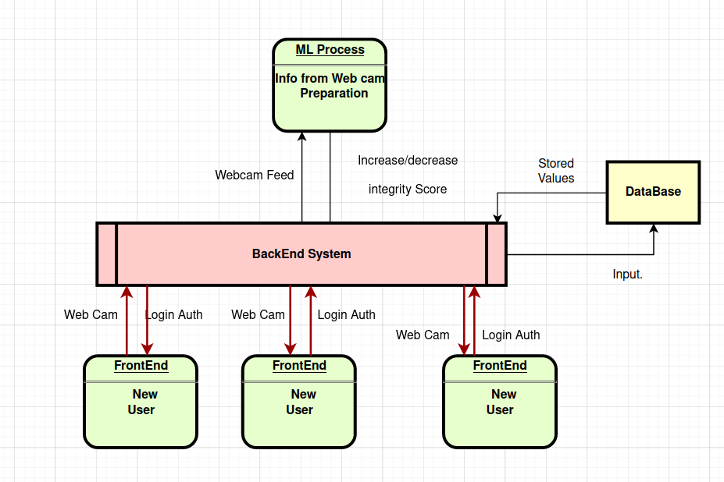

Appendix C: Issues List
< This is a dynamic list of the open requirements issues that remain to be resolved, including TBDs, pending decisions, information that is needed, conflicts awaiting resolution, and the like.>
- Complete Integration of Facial Movement.

